Area intercept charts

The first book on data visualisation I bought was *The Visual Display of Quantitative Information* by Edward Tufte. It came out in 1983 (there is now an updated second edition) and is part of the body of work and research that ushered in the Second Golden Age of Visualisation in the classification of the data viz expert and educator Albert Cairo.

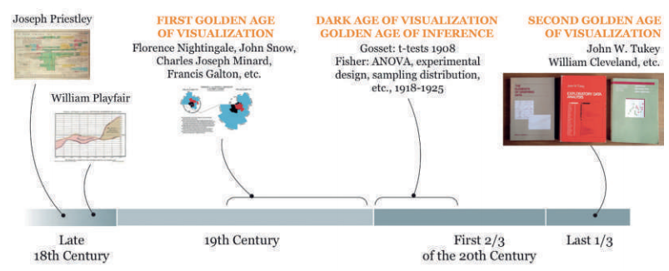

I know this now, but at the time I picked it up for my partner who was designing company reports in PowerPoint, and I thought it’d make a good present. The book itself was a large format hardcover with a near 5 star rating on Amazon and lots of colourful graphs. That was good enough for me.

So this is how I first came across the type of chart that is the subject of this blog post. You can see it in the timeline under its creator’s name, William Playfair.

Deconstructing this chart yields two time series, one for imports and one for exports with regions in-between the two lines shaded to show whether the balance of trade was favourable (exports are greater than imports) or not. The fact that the space between two discrete time series is made the focal point of the graph instead of being a mere by-product is what makes this graph so effective at communicating its message.

But for all its simplicity and elegance, this design was created using engraving techniques which aren’t exactly suited to our practical purposes (this is a Tableau blog after all!). So can we recreate it in Tableau?

Turns out that indeed we can, but not without some extensive data prep first.

http://powerfromstatistics.eu/uploads/originals/PDF/outlook-reports/PfS_Uncertainty%20and%20graphicacy.pdf